Project Design Phase-II
Technology Stack (Architecture & Stack)

Date | 31 January 3035
Team ID
Project Name | Import Data using Transform Maps (Spreadsheet)
Maximum Marks | 4 Marks

Technical Architecture:
The Deliverable shall include the architectural diagram as below and the information as per the table1 & table 2
Architecture: Import Data using Transform Maps (Spreadsheet) on ServiceNow
https://developer.ibm.com/patterns/ai-powered-backend-system-for-order-processing-during-pandemics/
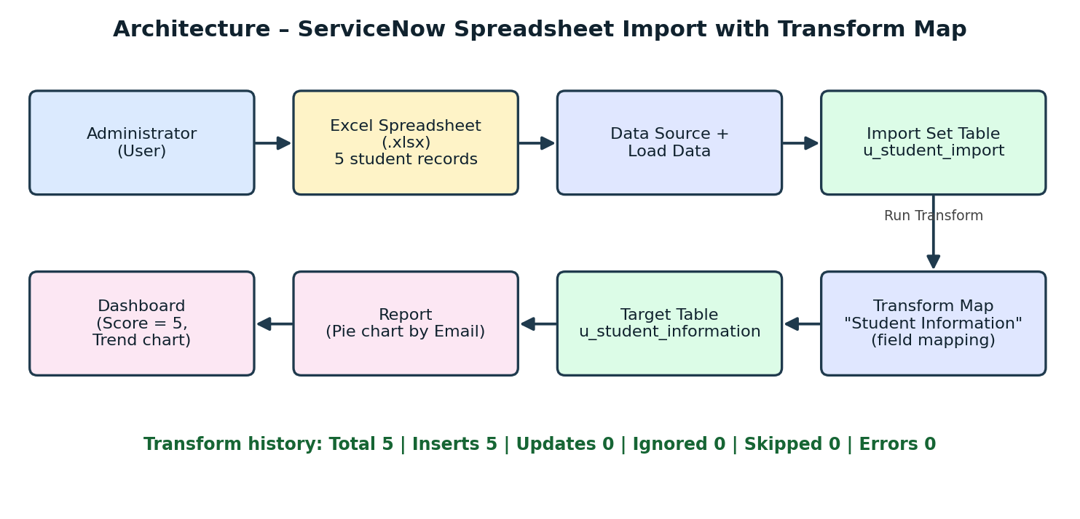

Table-1 : Components & Technologies:
S.No | Component | Description | Technology
1. | User Interface | Administrator uses the ServiceNow web UI to create the table, upload the spreadsheet and view reports/dashboards | ServiceNow Web UI, Microsoft Excel (.xlsx)
2. | Application Logic-1 | Data Source and Load Data: spreadsheet is loaded into the import set table u_student_import | ServiceNow Import Sets, Data Source
3. | Application Logic-2 | Transform Map "Student Information" maps source fields to target fields and inserts the records | ServiceNow Transform Map, Field Maps
4. | Application Logic-3 | Report and Dashboard: pie chart report by Email, single-score and line-chart widgets | ServiceNow Reports and Dashboards
5. | Database | Tables u_student_import and u_student_information; fields Student ID (Integer), Student Name, Department, Email (String), Year (Integer) | ServiceNow relational database
6. | Cloud Database | Database hosted with the cloud-based ServiceNow instance | ServiceNow Cloud Instance
7. | File Storage | Spreadsheet stored as an attachment on the Data Source record | ServiceNow Attachments (sys_attachment)
8. | External API-1 | Not used in this project | N/A
9. | External API-2 | Not used in this project | N/A
10. | Machine Learning Model | Not applicable to this project | N/A
11. | Infrastructure (Server / Cloud) | Application deployment on cloud. Local system: web browser only. Cloud server configuration: ServiceNow-hosted instance | ServiceNow Cloud

Table-2: Application Characteristics:
S.No | Characteristics | Description | Technology
1. | Open-Source Frameworks | Built on the ServiceNow low-code platform; no open-source framework needed | ServiceNow platform
2. | Security Implementations | Role-based access control and Application Access settings on the custom table | ServiceNow ACLs, Roles
3. | Scalable Architecture | Multi-tier cloud platform; the same Transform Map can be reused for larger files | ServiceNow multi-tier architecture
4. | Availability | Managed cloud hosting provided by ServiceNow | ServiceNow Cloud
5. | Performance | Import Set processing inserts 5 records in about 1 second | Import Sets, Transform Map

References:
https://c4model.com/
https://developer.ibm.com/patterns/online-order-processing-system-during-pandemic/
https://www.ibm.com/cloud/architecture
https://aws.amazon.com/architecture
https://medium.com/the-internal-startup/how-to-draw-useful-technical-architecture-diagrams-2d20c9fda90d

